Land and Environment Level 1 |   
Course Manager: Oliver Brooks-Adams Course Code: 13156-DSC-25

Please bring with you:

- Pens, coloured pencils, ruler, notebook
- File dividers or lever arch files
- Photo ID on your first day
- Work placement contact details
- It would be beneficial if you brought your own laptop or tablet

For practical sessions you will require these mandatory Items:

- S460 Yellow Padded Waterproof Hi Viz Coat
- C470 Yellow Hi Viz Vest
- FW16 or FW51 Steel Toe Capped Boots
- C1813 Liverpool Zip Black Overalls
- S556 Vanquish Waterproof Trouser Black
- S453 Plain Waterproof Bib & Brace Navy
- FW95 Steel Toe Capped Wellingtons Black / Green

Please note Hi-Viz is to be worn on the farm at all times; No Exceptions.

Bib and Brace – can be used during livestock and estate skills practical sessions.
Overalls – can be used at all other practical sessions and must be worn during machinery sessions.

The following item is optional
- A100 Hard Work Gloves

You will need to find a work placement to complete the mandatory work experience element. Once you have the employer’s details, please send them to jayne.darlington@duchy.ac.uk


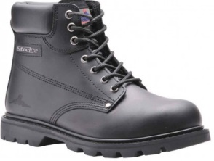
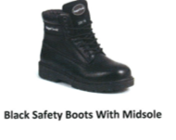


FW16 Steel Toe Capped Lace Up Boot

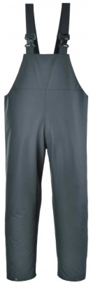
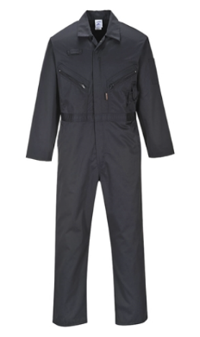
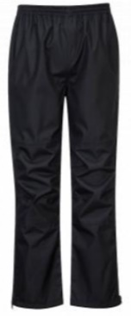

C1813 Liverpool Zip
Black Overalls
S453 Plain Waterproof
Bib & Brace Navy
S556 Vanquish Waterproof Trouser Black
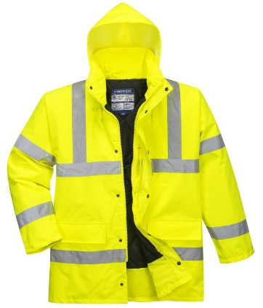
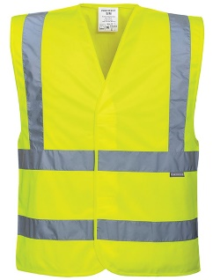
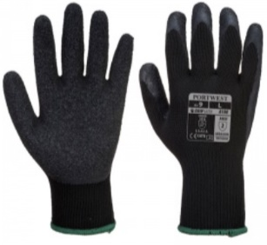

A100 Hard Work Gloves

C470 Yellow
Hi Viz Vest

S460 Yellow Padded
Waterproof Hi Viz Coat

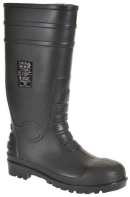
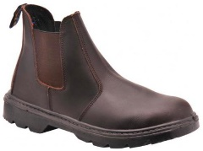
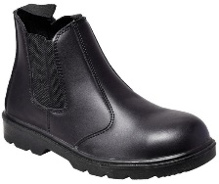
FW51 Steel Toe Capped Dealer Boot

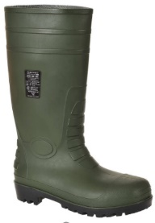

FW95 Steel Toe Capped Wellingtons Black / Green

Agriculture PPE, Prices and Ordering procedure
Red = Mandatory items for your Course
 |  |  |  |  |  |  |  |  |  |  |  |  |  |  |  | Quantity |  | Size |  |  | Price £
C183 Liverpool Zip Black Overalls |  |  |  |  |  |  |  |  |  |  |  |  |  |  |  |  |  |  |  |  | £28.00
S453 Plain waterproof bib and brace navy |  |  |  |  |  |  |  |  |  |  |  |  |  |  |  |  |  |  |  |  | £30.00
S556 Vanquish Waterproof Trousers |  |  |  |  |  |  |  |  |  |  |  |  |  |  |  |  |  |  |  |  | £24.00
S460 Yellow padded waterproof Hi-Viz coat |  |  |  |  |  |  |  |  |  |  |  |  |  |  |  |  |  |  |  |  | £32.00
C470 Yellow Hi-Viz vest |  |  |  |  |  |  |  |  |  |  |  |  |  |  |  |  |  |  |  |  | £8.50
FW16 Steel toe capped lace up boots |  |  |  |  |  |  |  |  |  |  |  |  |  |  |  |  |  |  |  |  | £32.00
FW51 Steel toe capped dealer boots (brown / Black) |  |  |  |  |  |  |  |  |  |  |  |  |  |  |  |  |  |  |  |  | £30.00
FW95 Steel toe capped wellington boots |  |  |  |  |  |  |  |  |  |  |  |  |  |  |  |  |  |  |  |  | £18.00
A100 Hard work gloves (Black) |  |  |  |  |  |  |  |  |  |  |  |  |  |  |  |  |  |  |  |  | £1.30
For sizing, please google the product name to determine the size required |  |  |  |  |  |  |  |  |  |  |  |  |  |  |  | Sub-Total
 |  |  |  |  |  |  |  |  |  |  |  |  |  |  |  | VAT (20%)
 |  |  |  |  |  |  |  |  |  |  |  |  |  |  |  | Total
Garments include logo and course name where appropriate
Complete the form ensuring that you write your FULL name in BLOCK Capitals
Add the prices up and put the TOTAL price at the bottom
E mail or post your completed form to JOG Safety (detail below)
Payment either by cheque or Bank Transfer (BACS)
Cheques to be made payable to JOG Safety Workwear & Leisure Ltd.
JOG Bank details:
Lloyds Bank, Molesworth Street, Wadebridge PL27 7DE
Sort Code 30 98 98
Account number 01590412
JOG Safety Workwear & Leisure Ltd.
Unit 5 Victoria Gardens
St Columb Road
Cornwall
TR9 6QR
01726 861500
jogsafety@hotmail.co.uk
STUDENT first name: ……………………………………. Surname: ……………………………………………….

Student telephone number (Home): ………………………………………………………. Mobile: ………………………………………………
Completed paid for orders will be delivered to Duchy College
DATE: …………………………………………….

