# **Welcome to Hospitality & Catering**

We are looking forward to you joining us in the autumn. You may have studied this subject already, or this might be completely new to you. Whatever your starting point, we are ready to support you with your learning.

You will find a range of resources below to help you prepare for your course. Keep notes about what you have found out or learnt to support your learning later on.

# **Read**

Editorials - Books | Magazines | Newspapers

There are lots of Magazines available that are paper based and online about Hospitality and Catering.

These magazines have key articles, facts and figures and about the sector and lots of jobs for you to browse through.

# The following is about how the hospitality industry may have to change post COVID-19 April 27, 2020

– Very topical at the moment!! Click here to access this article:

[Reopening restaurants during social distancing “impossible and implausible”](https://www.bighospitality.co.uk/Article/2020/05/05/Restaurants-reopen-London-UK-Coronavirus?utm_source=copyright&utm_medium=OnSite&utm_campaign=copyright)

05-May-2020 By Stefan Chomka



A number of London’s top restaurateurs have pushed back at the idea of reopening their venues while physical distancing measures designed to curb the spread of Coronavirus are in place.

Also

<https://www.hospitalityandcateringnews.com/2020/04/future-workplace-catering-forecast/>

### **Experts urge businesses to adapt and prepare for significant change to workplace catering.**

### **Workplace ‘takeaways’, shift-based lunches and more pre-ordering are all likely to be the new ‘normal’ when the Covid-19 crisis has passed.**

### **Foodservice experts discuss how the future workplace will look.**

With more people expected to work from home, an introduction of ‘shift’ patterns, and a gradual removal of lockdown measures, the workplace will change significantly.

### **Reshaping menus**

Food offers for a post COVID-19 world will need to change dramatically. Menus will need to be more ‘delivery’ friendly, or be able to be hosted in newly designed workplace restaurants.

Any sharing, or self-service style food to be removed

### **Health and safety**

Specific training and development will be required by teams in a new socially-distanced environment.

Customers and guests will need to be offered guidance and information about new ways of working and measures taken to minimise risk.

Restaurant hosts and guides are likely to be deployed to guide people through zones and control the movement of people.

### **Future workplace catering forecast – Shift based footfall**

Some city businesses are likely to implement shift patterns for those who come to the office. ‘A’ and ‘B’ teams are likely to be deployed on a weekly basis.

There are likely to be lunch shifts in some organisations to reduce traffic and queuing wherever possible.

### **Future workplace catering forecast – Intelligent technology**

There will be more emphasis on using technology to pre-order food.

Technology will communicate key messages to customers and guests to help reassure them during the initial post-lockdown period.

‘Click and collect’ is expected to feature heavily during the initial months.

# **Food for thought!!!**

**Think about how you would change the way we eat in the future, whether it is high end, or fast food dining?**

**---------------------------------------------------------------------------------------------------**

# **Watch**

TV | Movies | You Tube

In the mood for some challenging culinary inspiration? Or simply feel like putting up your feet, ordering a takeaway and watching Come Dine With Me Marathon? From Dinner Date to MasterChef, there are so many programs on TV and You Tube about the Hospitality and Catering sector you are quite literally spoilt for choice

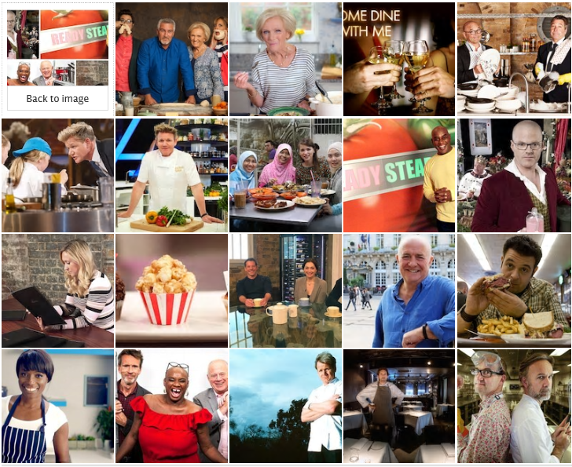

**Listen**

Podcast | Radio | Audible

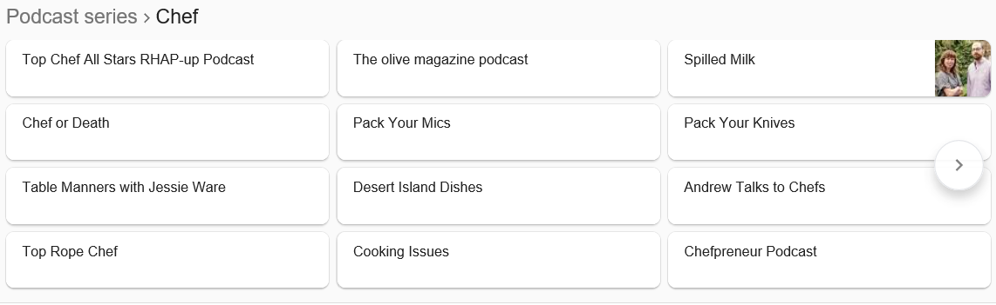**Grilled by The Staff Canteen** now brings all of our chef interviews straight to your phone as audio! You no longer need to read what your favourite chefs have to say, you can listen when you want and where you want! Plus, they are full of extra juicy bits you won't get on our website.  
  
The Staff Canteen is the number one site for chefs, make sure you become a member to get news, debtaes, videos and jobs first.

<https://podcasts.apple.com/gb/podcast/grilled-by-the-staff-canteen/id1470936798>

**---------------------------------------------------------------------------------------------------**

# **Get Involved**

Competitions | Social Media | Webinar

And finally, we are holding a webinar on xxx where you can find out more about a career in Hospitality & Catering. You will have an opportunity to hear about the steps you need to take in order to become qualified in our sector, ask questions and apply for the right route for you.

Register here.