Step by step guide to ‘Focus Stacking’ in Photoshop

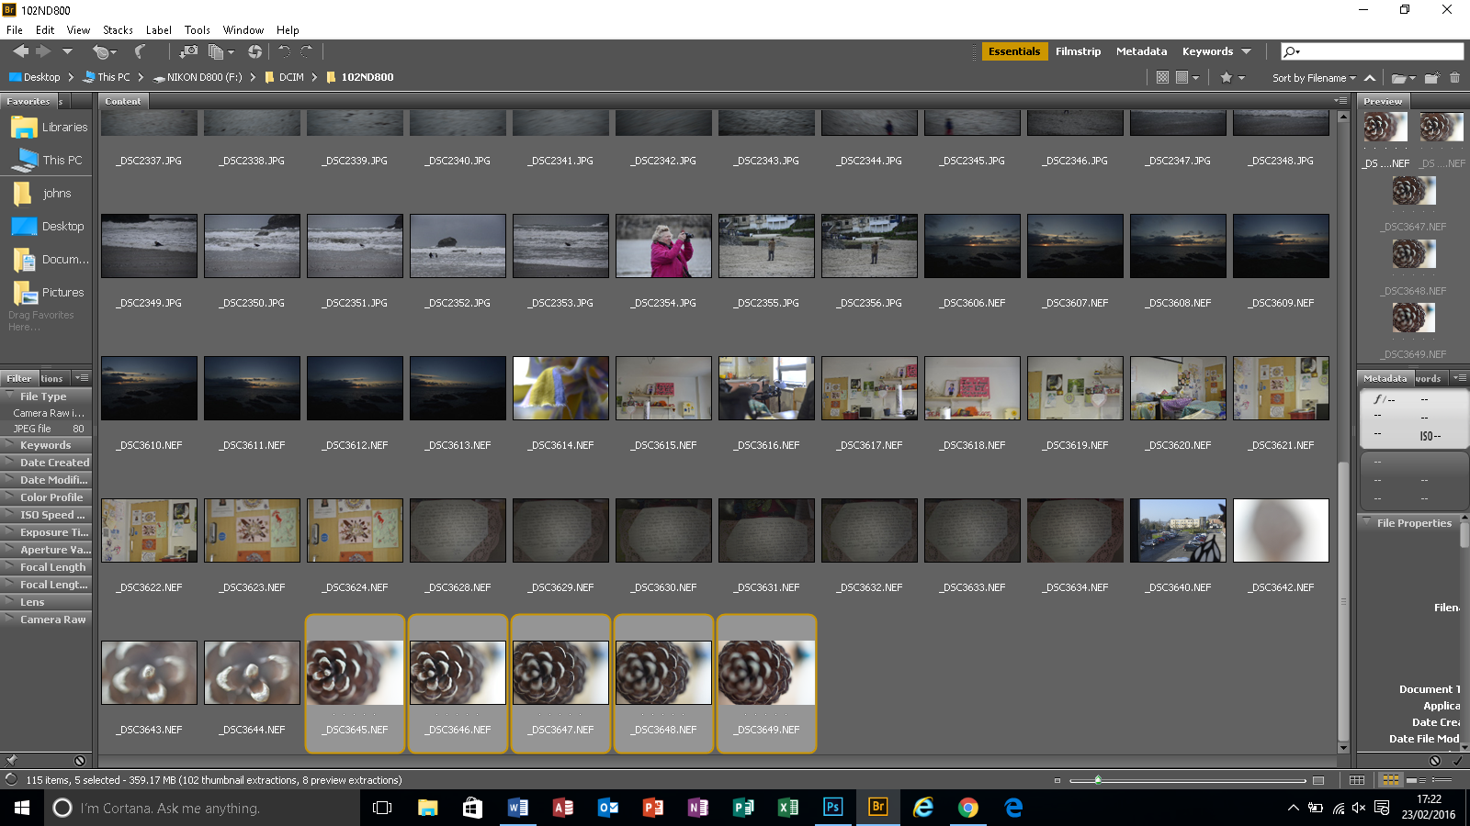

In Bridge (comes with Photoshop), select the all images that you wish to focus stack

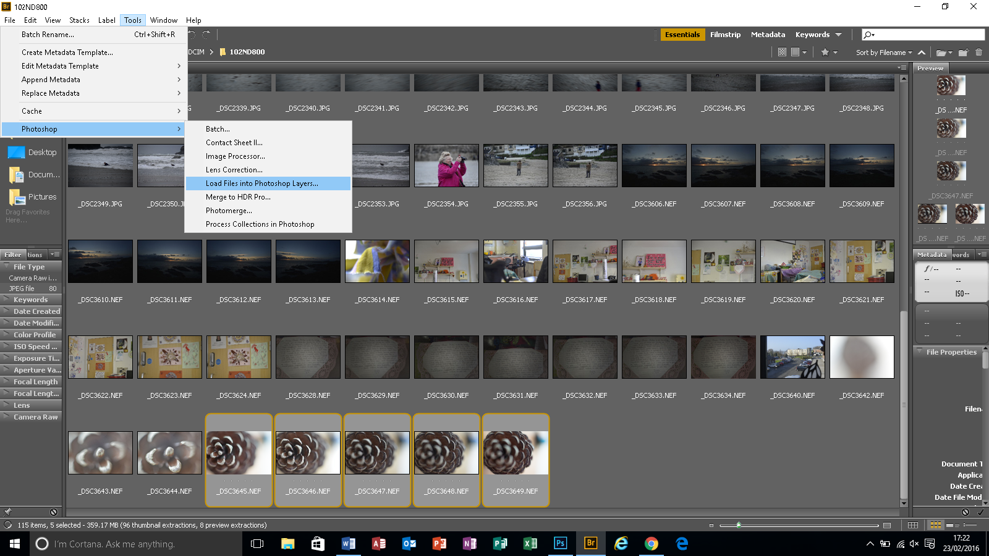

Then select tools > Photoshop > load files into Photoshop layers

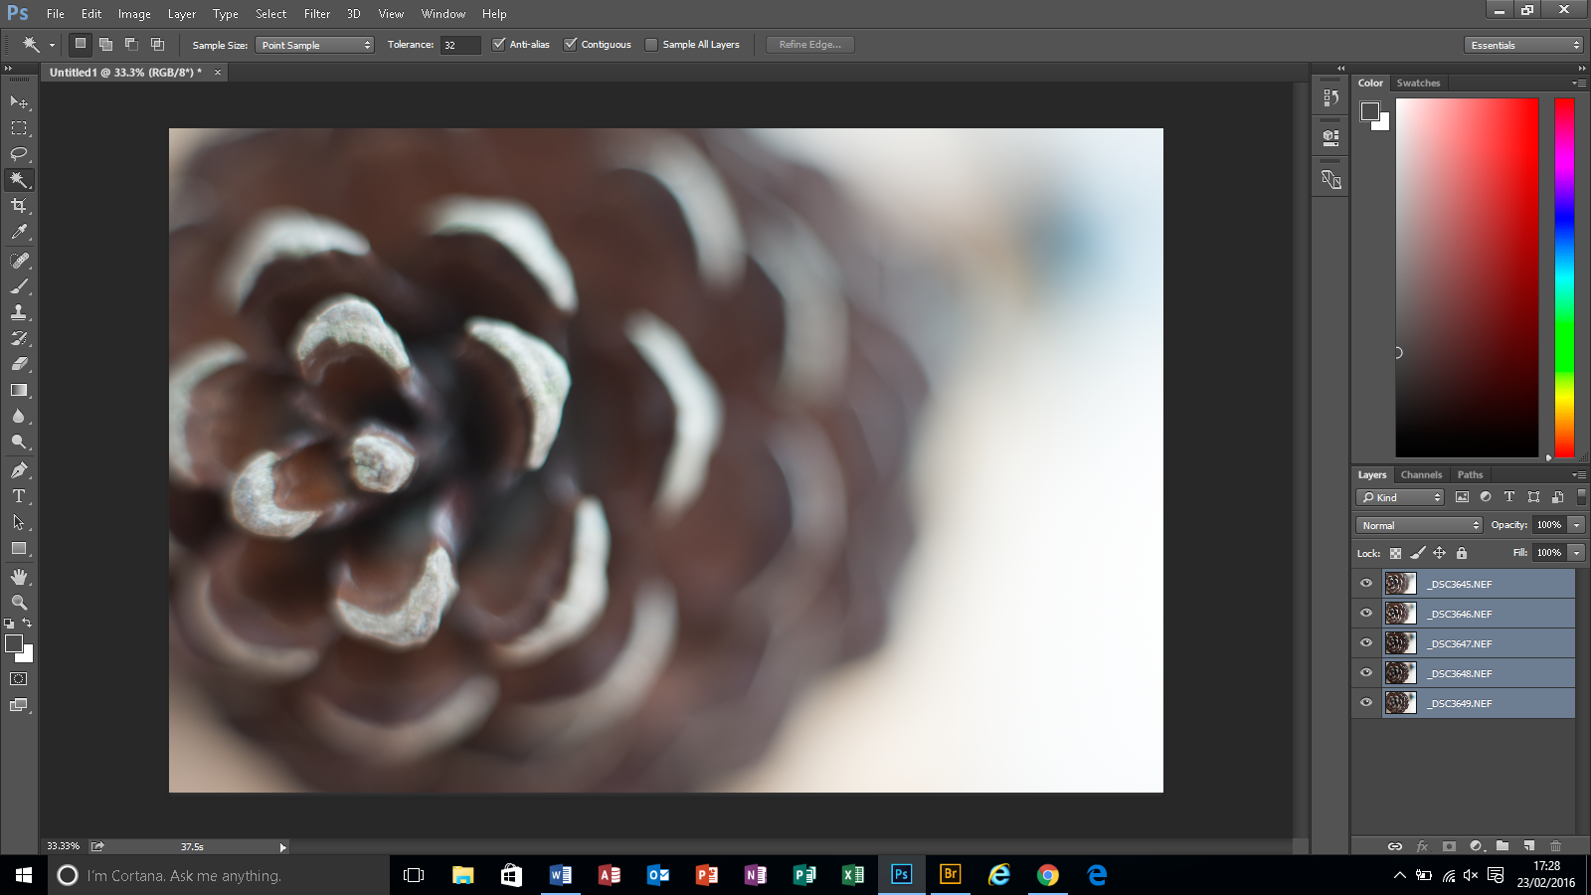

This will be quicker with jpegs than raw, but eventually the images will all load – press shift and click on the bottom layer to select all layers

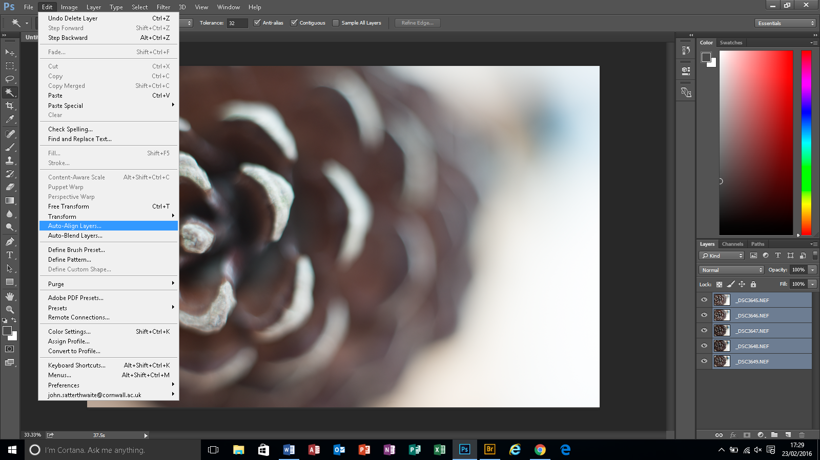
Then select edit > auto align layers

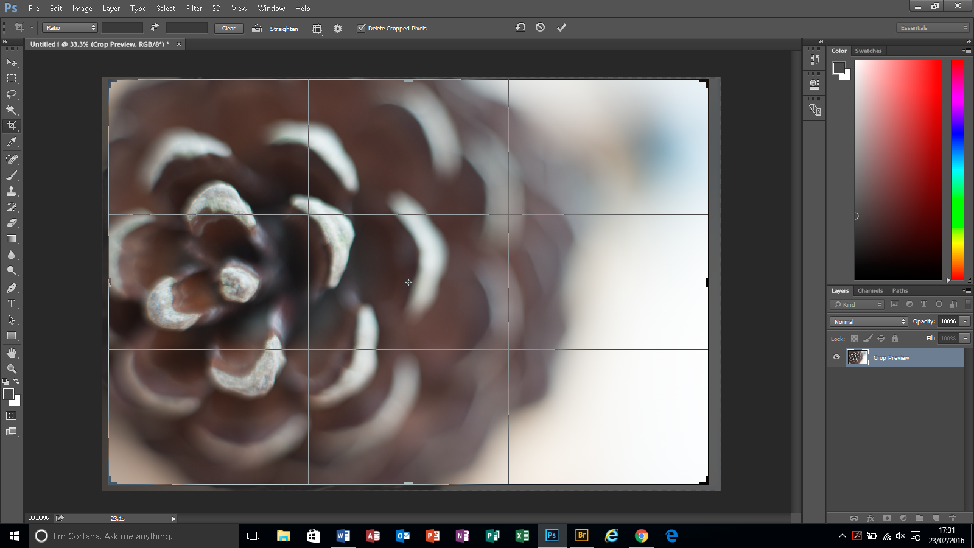

Select the crop tool and trim any ‘surplus’ edges

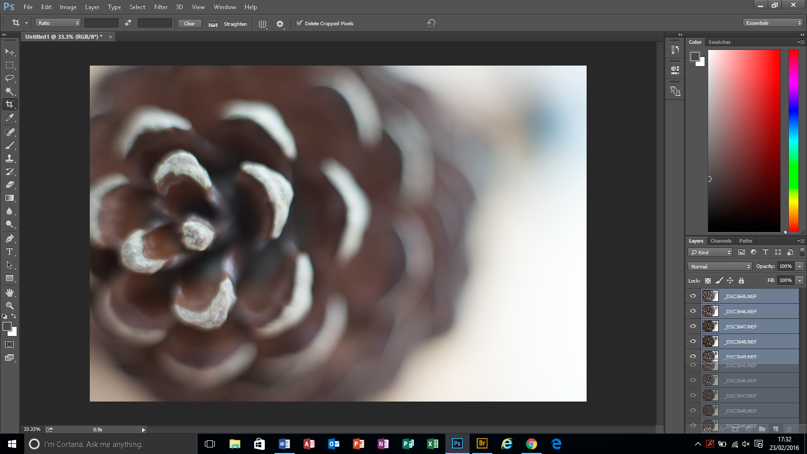

Select the block of layers and drag down to the ‘create new layers’ icon to create copies

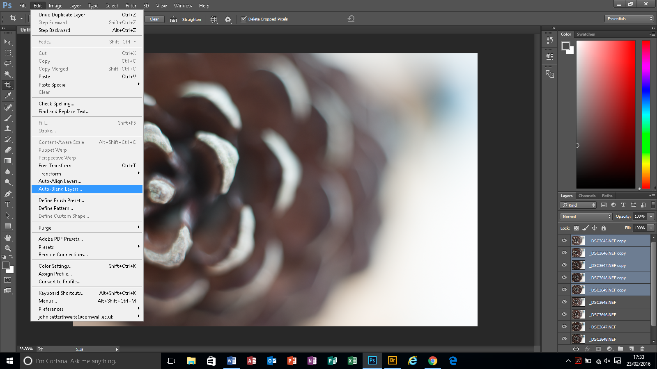

Then select edit > auto blend layers

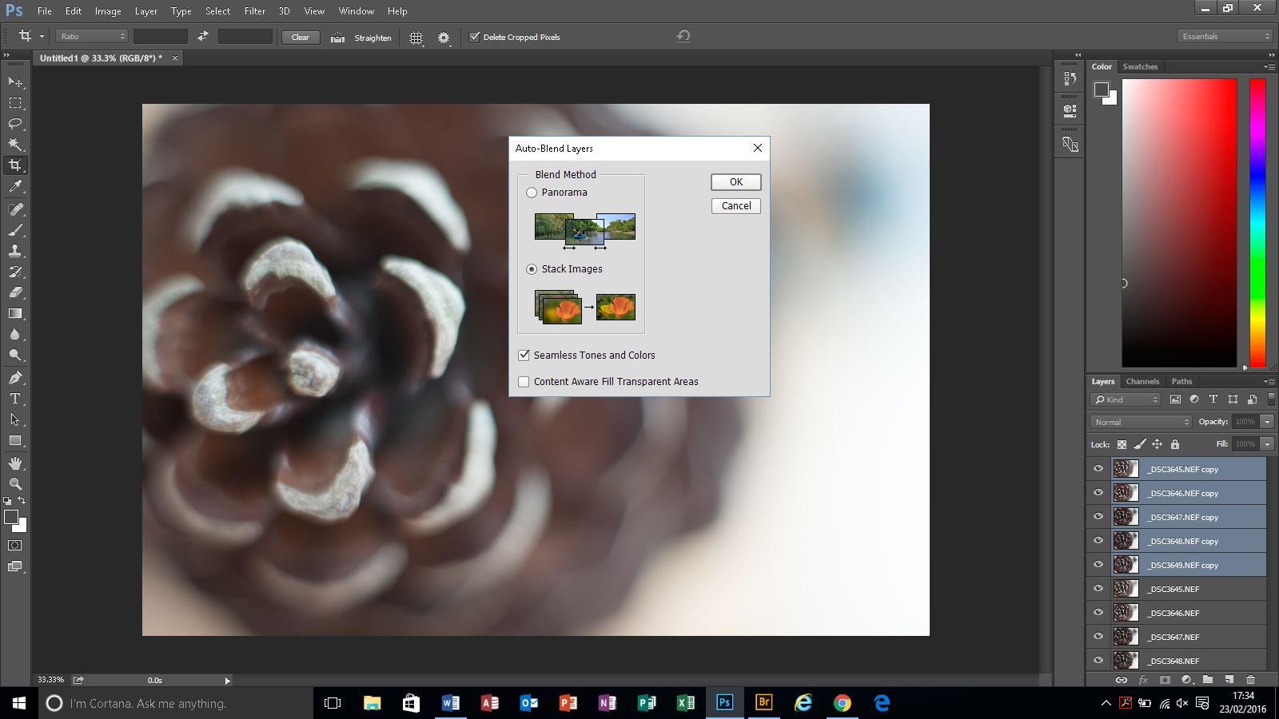

Make sure ‘stack images’ and ‘seamless tones and colours are selected’ and press OK

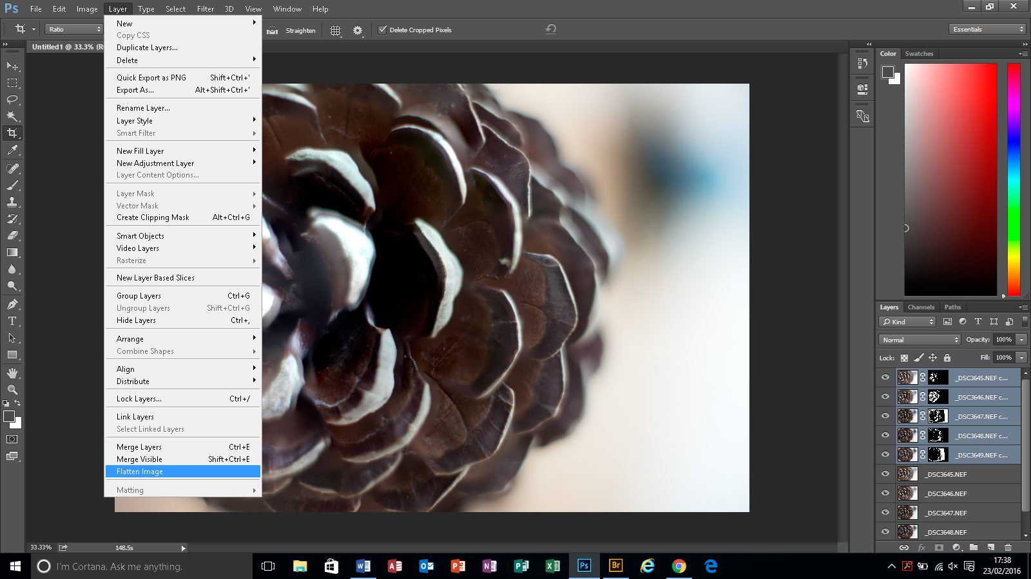

Then select layer > flatten image

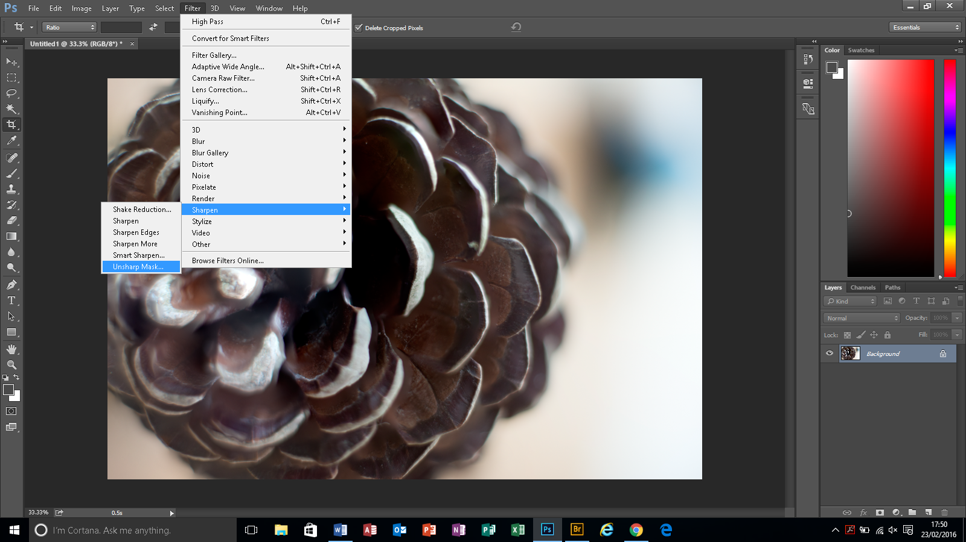

I prefer to use unsharp mask – select filter > sharpen > unsharp mask

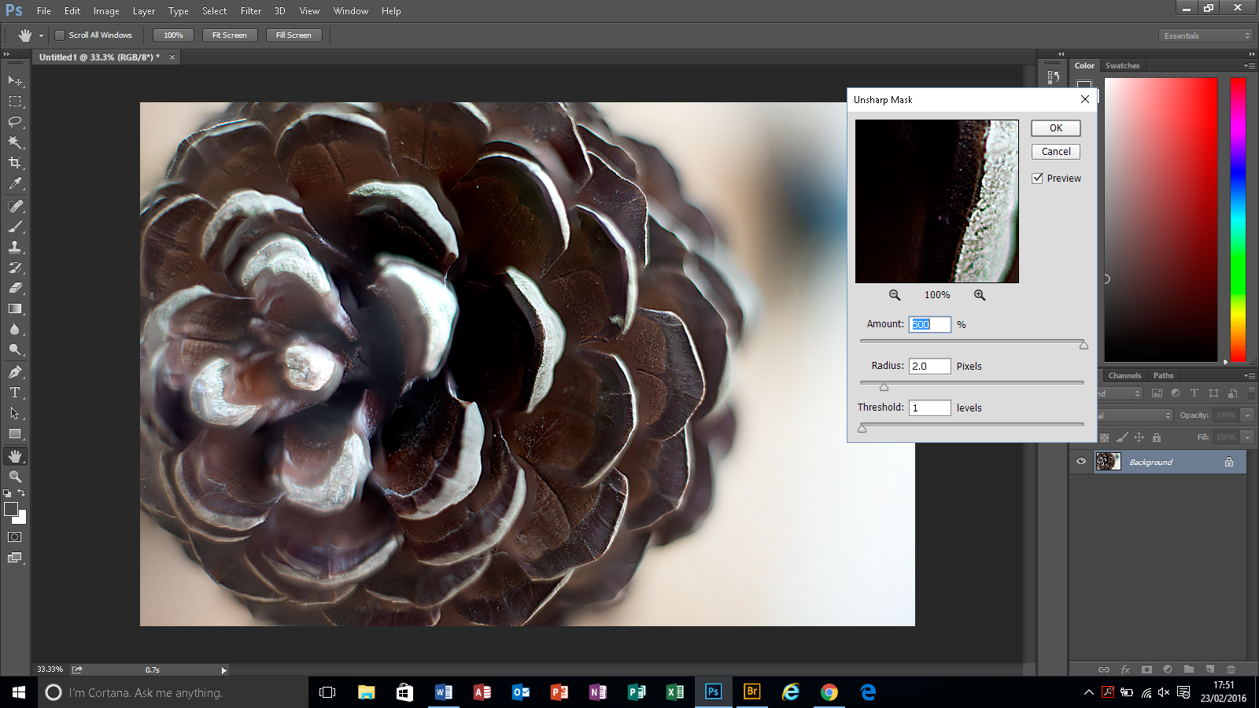

With a threshold of 1 and a radius of 2, vary the ‘amount’ slider until you are happy with the result

Then press ‘OK’ and save your image as a TIFF or JPG depending on your starting point !

Well Done!

