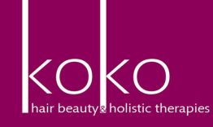BEAUTY/SPA BOOK LIST 2022/2023

Dependant on your chosen course you must purchase one of the following books. They can be brought at most good book stores or online at Amazon.

|  |  |  |  |  |
| --- | --- | --- | --- | --- |
| **Book** | **Title** | **Author** | **ISBN Number & Price** | **Tick if Book required** |
|  | Level 2 VRQ Diploma in Beauty Therapy | Helen Beckmann, Kelly Rawlings | 978085193 2040  £23.00 |  |
|  | Anatomy and Physiology therapy basics | Helen Mcguinness | £30.00 |  |

|  |  |  |  |  |
| --- | --- | --- | --- | --- |
| **Book** | **Title** | **Author** | **ISBN Number** | **Tick if Book required** |
| \\sac-treamble\users\francine.clapham\My Documents\memory stick\memory stick\Book Order Forms 2014\Spa book picture.png | The Official Guide to Spa Therapy | Joan Scott & Andrea Harrison | 9781844803125  £28.00 |  |
|  | The complete Nail technician | Marian Newman | £35.00 |  |