BOOKS RECOMMENDED FOR LEVEL 4 SPORTS MASSAGE 2022/2023
Book | Title | Author
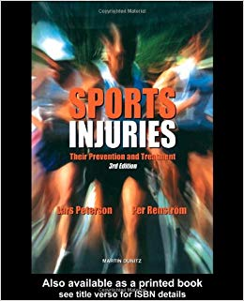 | Sports Injuries  ISBN: 9781853171192  Hardback  ISBN: 1853171190  Approx. (£45.00) | Lars Peterson
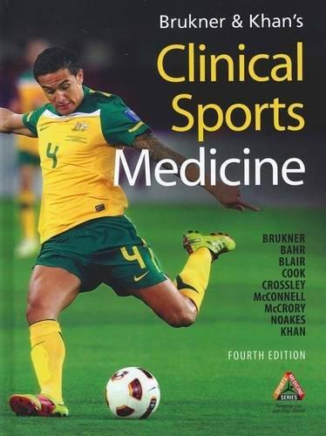 | Clinical Sports Medicine  ISBN: 9780070998131  Hardback  ISBN: 0070998132  Approx. (£60.00) | Peter Brukner  &  Karim Khan
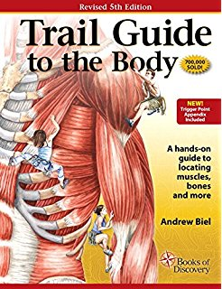 | Trail Guide to the Body  ISBN: 0982978650  Approx. (£50.00) | Andrew Biel
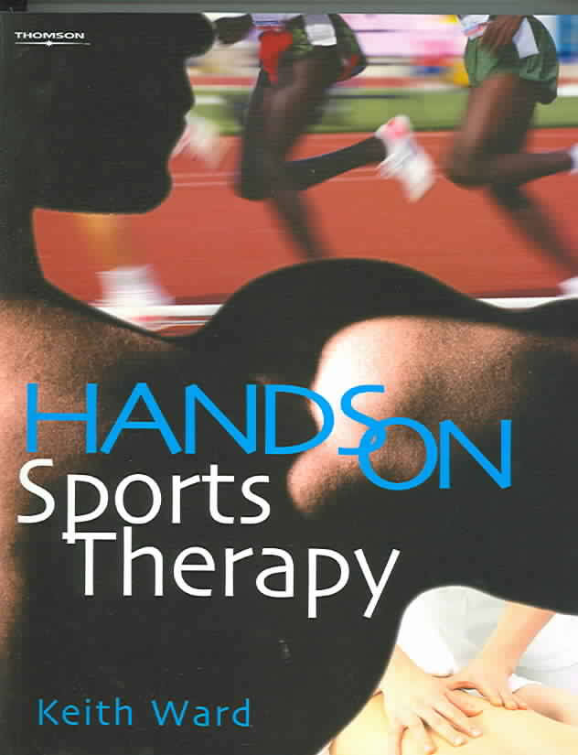 | Hands on Sports Therapy  ISBN: 1861529201  Approx. (£30.00) | Keith Ward
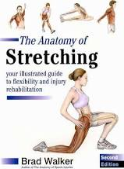 | The Anatomy of Stretching  Paperback  Approx. (£8.86) | Brad Walker

