BOOKS RECOMMENDED FOR LEVEL 3 SPORTS MASSAGE
AVAILABLE FROM AMAZON OR WORLD OF BOOKS
Book | Title | Author | ISBN Number
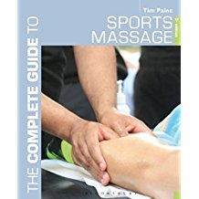 | Complete Guide to Sports Massage, The (Complete Guides) Paperback | Tim Paine | ISBN: 978-1472912329
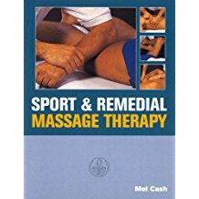 | Sports and Remedial Massage Therapy | Mel Cash | ISBN: 978-0091809560
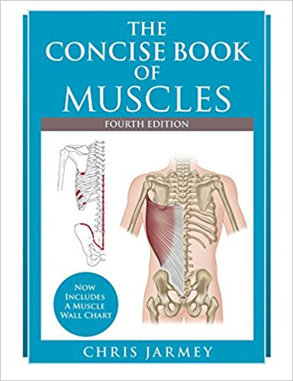 | The Concise Book of Muscles | Chris Jarmey | ISBN: 978-1905367863

